$GNGGA,144341.000,,,,,0,00,25.5,,,,,,\*7D

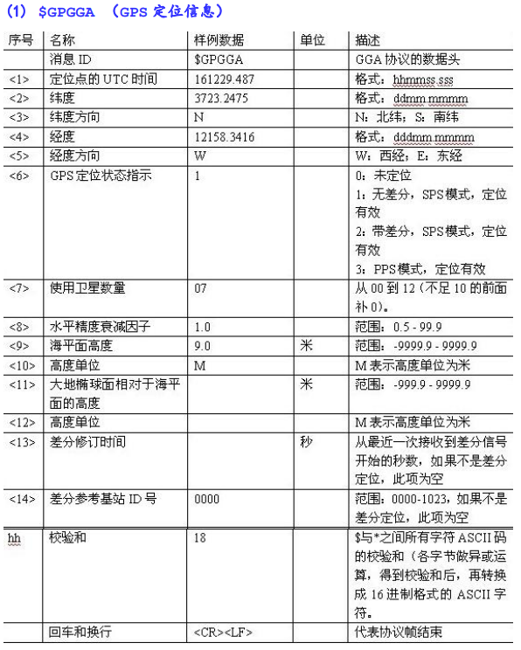

$GNGLL,,,,,144341.000,V,N\*63



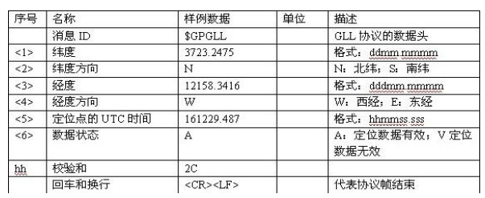

$GPGSA,A,1,,,,,,,,,,,,,25.5,25.5,25.5\*02

$BDGSA,A,1,,,,,,,,,,,,,25.5,25.5,25.5\*13

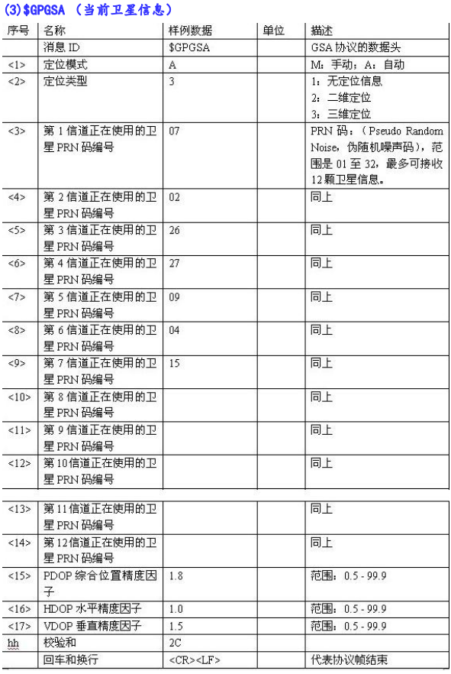

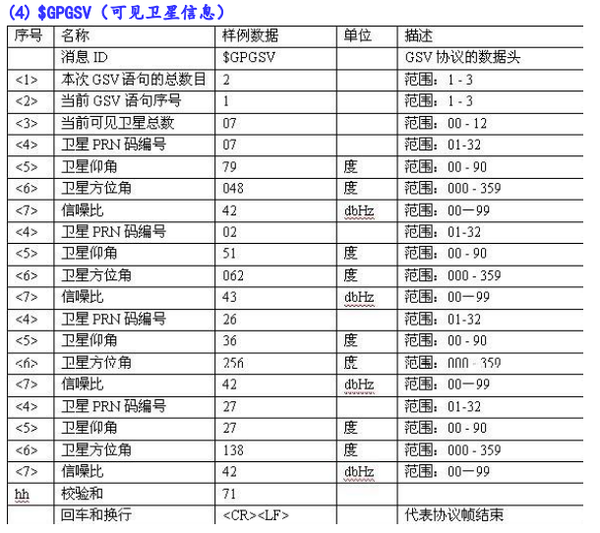

$GPGSV,1,1,04,20,,,36,28,,,29,193,,,34,195,,,21\*79

$BDGSV,1,1,01,10,,,36\*6D

$GNRMC,144341.000,V,,,,,,,010222,,,N\*57

$GNVTG,,,,,,,,,N\*2E

$GNZDA,144341.000,01,02,2022,00,00\*4E

$GPTXT,01,01,01,ANTENNA OK\*35

$GNGGA,144342.000,,,,,0,00,25.5,,,,,,\*7E

$GNGLL,,,,,144342.000,V,N\*60

$GPGSA,A,1,,,,,,,,,,,,,25.5,25.5,25.5\*02

$BDGSA,A,1,,,,,,,,,,,,,25.5,25.5,25.5\*13

$GPGSV,1,1,04,20,,,35,28,,,29,193,,,34,195,,,21\*7A

$BDGSV,1,1,01,10,,,36\*6D

$GNRMC,144342.000,V,,,,,,,010222,,,N\*54

$GNVTG,,,,,,,,,N\*2E

$GNZDA,144342.000,01,02,2022,00,00\*4D

$GPTXT,01,01,01,ANTENNA OK\*35